2024
MASTER PLAN
GRANT PROGRAM
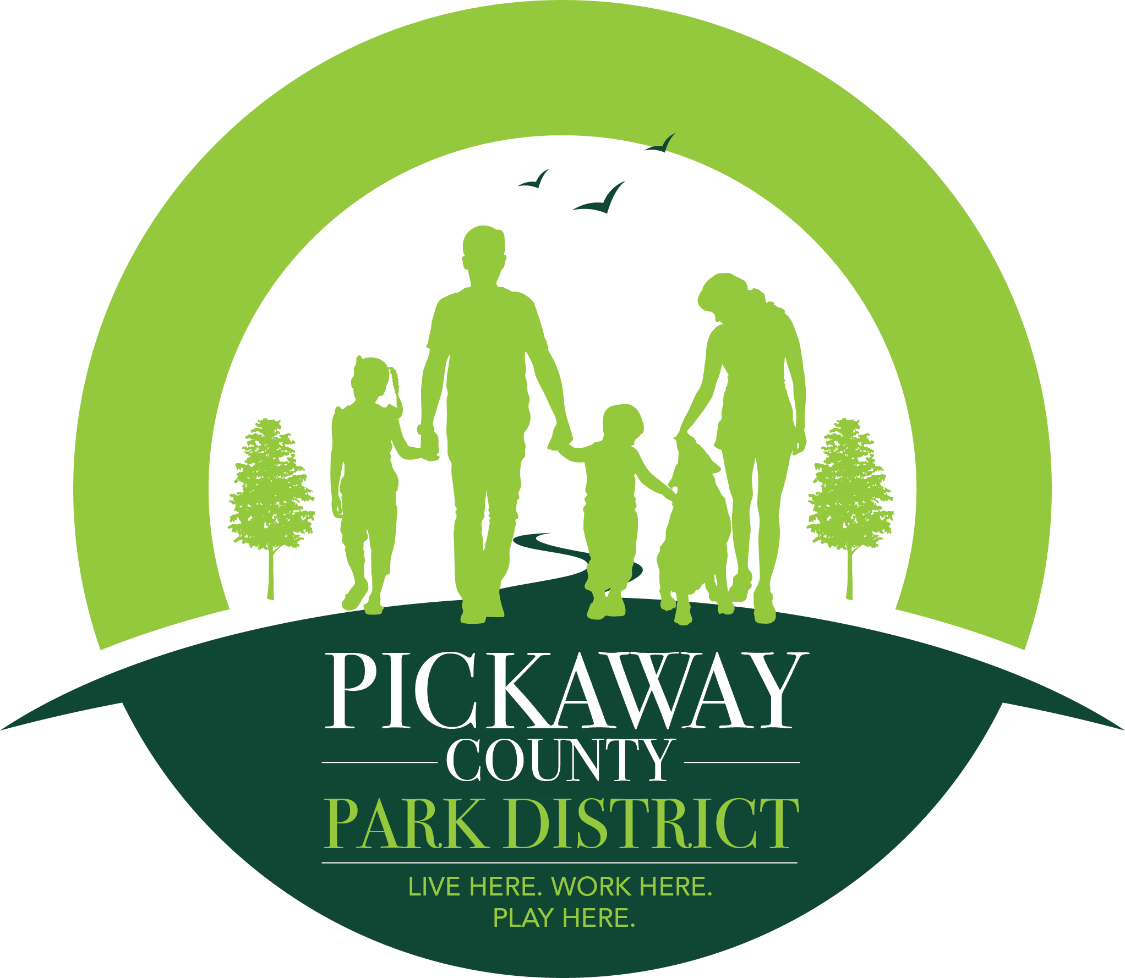

Park and Trail Grant Program Summary: Since 2015, the Pickaway County Park District has awarded over $520,000 to support 66 local park and trail projects here in Pickaway County.
In November of 2017, the citizens of Pickaway County approved a 10-year levy to support Park District operations and to increase and improve parks and trails throughout the county. To follow through with promises made during the levy campaign, the Park District has again set aside $75,000 of its 2024 appropriations, for the 10th round of park and trail grants. This year the District has expanded this grant program to include the option to request fund for a Park Master Plan, Master Plan Improvement Projects or Park and Trail Improvements. Applicants may submit applications for both the Master Plan Grant and the Park Improvement Grant within the same cycle or may submit an application for a Master Plan Improvement Project. Applicants submitting projects under both grants will be required to identify their priority project. $20,000 will be dedicated for the creation of local park master plans and $20,000 will be dedicated for park and trail improvement projects. Applicants who have completed a Master Plan Project with the District who are applying for a Master Plan Improvement Grant will be eligible for up to $50,000 to complete a project within the scope of the park’s master plan. Please see each individual grant application for more details.

Who is Eligible to apply: Cities, villages, townships within Pickaway County. Schools and nonprofits are currently not eligible applicants. Nonprofits may request funds through a township or village if applicable.

How much are we allowed to request: Applicants may request funds for a master plan for one park per grant cycle. If you do not currently own park or trail property you are eligible to apply for a master plan for the purchase and creation of a new park. Master Plan costs vary depend on the size and activity desired for your park. Therefore, if your application is selected for funding, the Park District will be contracting with a park planning consultant to work with you on completing the master plan.

Do we have to provide a cash match in order to apply/receive a Grant: No Cash match is required.

Are there any special requirements should we receive a grant: If you are selected to receive a Pickaway County Park District Park and Trail Master Plan Grant you will be required to attend a minimum of three (3), in person, planning meetings with the District and the master plan consultants, assist with community surveys (which could include funds to pay for mailers), host a minimum of one (1) public meetings for input on your master plan and correspond accordingly through email and phone with the District and master plan consultants.

Note: If you received a grant in 2023, and have not yet completed the project, or have not completed all parts of your Final report, you will not be eligible to apply for funds in 2024.

How do you make application for the 2024 Park and Trail Master Plan Grant: To make application for a 2024 PCPD Park and Trail Master Plan Grant, complete Forms 1 through 3 and mail them, along with all appropriate attachments, to the Pickaway County Park District, 548 Lancaster Pike, Circleville, Ohio, 43113. You may also drop off your completed application to the Pickaway County Park District office in our drop box at the above address or email the completed application to ahartzler@pickawaycountyohio.gov . You can print an application off from our website at https://www.pickawaycountyparks.org/about-us/ptig/ or pick up a copy in our office. Applications must be received by 4PM Friday December 15th, 2023. Please note that your you contact persons must be reachable by email and phone. Our primary mode of contact will be through email.

Program process/timeline: All grants are scored by a committee based on several factors, including, past performance (if applicable), relevance of the project to the District’s mission, and timeliness. To see an example of the scoring criteria rubric please contact Arista Hartzler at ahartzler@pickawaycountyohio.gov. Grants will be announced on or before January 25th, 2024. A grant agreement will be mailed to the grantee shortly thereafter detailing the grant award and the process for receiving payment. Once you receive a copy of the signed agreement the District will begin coordinating with the master plan consultant on your behalf to start the work for the master plan. All grant projects, with all components of the Final Reports, must be completed and received by the District by 4pm November 1st 2024 to receive reimbursement. If you do not complete the final report you are not eligible to apply in the next grant cycle.

Form # 1- General Project Information
Applicant Agency:

Applicant Agency Phone:

Applicant Agency Mailing Address:
(must be the address where you can receive mail)

Agency Contact Person:
(Person available during Normal Work Hours)
Email of Agency Contact Person:

Phone Number of Agency Contact Person:
Secondary Agency Contact Person:
Secondary Email of Agency Contact Person:
Secondary Phone Number of Agency Contact Person:

Project Title:

Project Location:

Letters of Support: | (Attach Any Letters of Support at End of Application)
Photos of Location, Existing Park Features, Existing Plans for Park and Other Maps: | (Attach to End of Application)

Form # 2- Detailed Project Description
Describe IN DETAIL the existing need for this park to have a Master Plan
(please explain your project fully, with specific details explaining why your project should be considered):

*If you need more space please attach pages

Describe IN DETAIL your vision for the future of this park. What features do you think your park is lacking? What amenities do you feel you community would like to see at this park?:

*If you need more space please attach pages

Form # 3 – Authorizing Resolution
Below is an example of a form that is required to be submitted with each application. This form, or one similar to it, identifies that the officials responsible for the actions of the applicant agency are aware and supportive of the proposed project, and commit the appropriate agency funds to complete the proposed grant project.
RESOLUTION OF AUTHORIZATION
WHEREAS, the Pickaway County Park District administers a financial assistance program for public outdoor recreation purposes, through the 2024 Park and Trail Grant Program, and

WHEREAS, the ___________________________________ desires financial assistance under
(Name of applicant)

the Park and Trail Grant Program.

NOW, THEREFORE, be it resolved by the _______________________________________
(Name of applicant)

- That the ____________________________________ approves filing an application
(Name of applicant)
for financial assistance.

- That ____________________________________ is hereby authorized and directed
(Name of local coordinator)

to execute and file an application with the Pickaway County Park District and to provide all information and documentation required to become eligible for possible funding assistance.

- That the ____________________________________ is aware and supportive of the proposed project and has the necessary funds
(Name of applicant)

appropriated in it’s 2024 budget to complete the project as outlined in this grant application, should the grant request be awarded.

Signed: _____________________________________________________________
(Authorized Agency Official)

Title: ____________________________________Date: ________________________________

Signed: _____________________________________________________________
(Applicant Agency Fiscal Officer)

Title: ____________________________________Date: _________________________________

