2024
PARK AND TRAIL
IMPROVEMENT GRANT PROGRAM
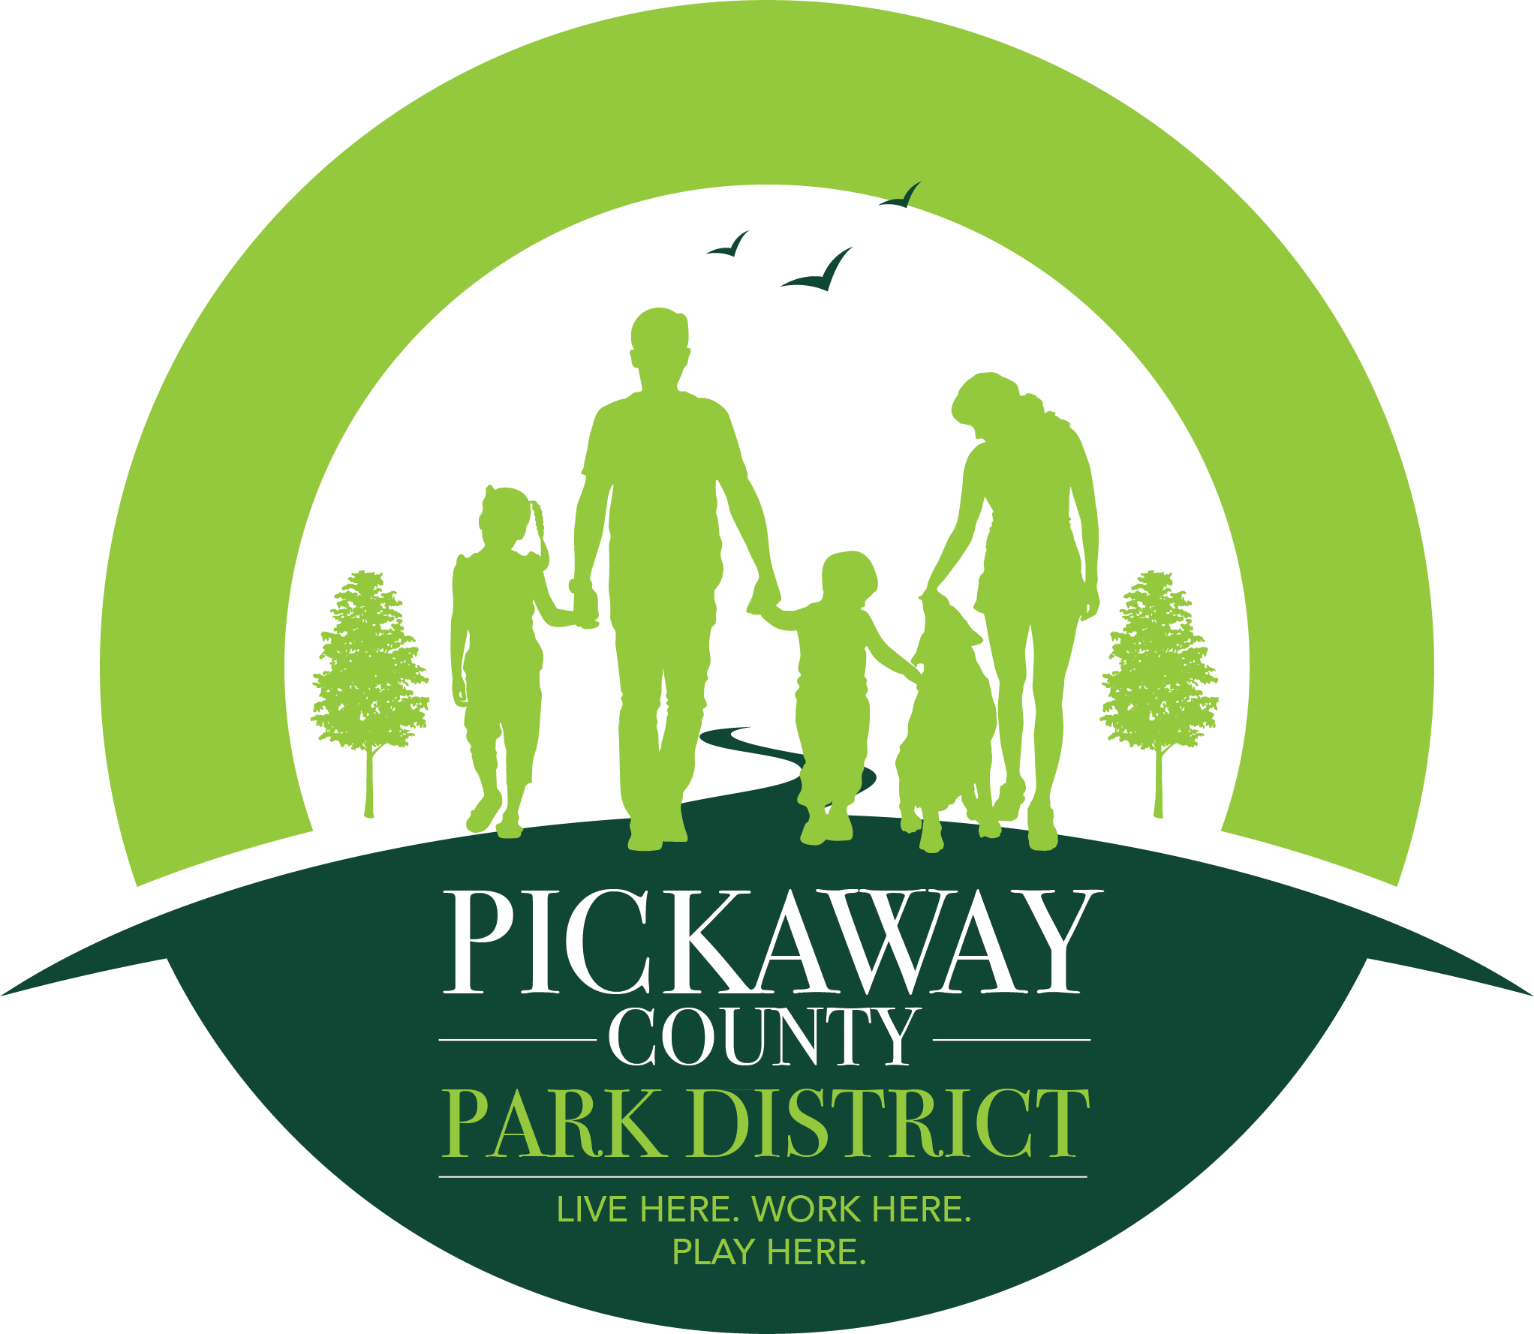
Park and Trail Grant Program Summary: Since 2015, the Pickaway County Park District has awarded over $520,000 to support 66 local park and trail projects here in Pickaway County.
In November of 2017, the citizens of Pickaway County approved a 10-year levy to support Park District operations and to increase and improve parks and trails throughout the county. To follow through with promises made during the levy campaign, the Park District has again set aside $75,000 of its 2024 appropriations, for the 10th round of park and trail grants. This year the District has expanded this grant program to include the option to request fund for a Park Master Plan, Master Plan Improvement Projects or Park and Trail Improvements. Applicants may submit applications for both the Master Plan Grant and the Park Improvement Grant within the same cycle or may submit an application for a Master Plan Improvement Project. Applicants submitting projects under both grants will be required to identify their priority project. $20,000 will be dedicated for the creation of local park master plans and $20,000 will be dedicated for park and trail improvement projects. Applicants who have completed a Master Plan Project with the District who are applying for a Master Plan Improvement Grant will be eligible for up to $50,000 to complete a project within the scope of the park’s master plan. Please see each individual grant application for more details.

Who is Eligible to apply: Cities, villages, townships within Pickaway County. Schools and nonprofits are currently not eligible applicants. Nonprofits may request funds through a township or village if applicable.

Note: Priority will be given to those who have not received funding previously or those who have received the least amount of funding in the past.

What are the Eligible uses of grant monies: Costs associated with the improvement of existing park or trail facilities, or the purchase or development of new park or trail facilities in Pickaway County. The Park or Trail facility must be owned or leased (minimum 15-year lease) by the applicant and must be open to the general public for use. Applicant may only request one park and trail improvement project per park. If applicant makes multiple applications for different parks a priority project must be identified.

Potential projects might include: purchase of benches, waste receptacles or play structures for your park or trail facility; building of picnic shelters, dog or skate parks, repairs to playground or shelters, repairs to existing trails, replacing mulch, landscaping and/or assistance with the purchase of property for new trail or park facilities. Cost associated with daily operations, such as mowing and salaries are not eligible.

How much are we allowed to request: Applicants may request funds for up to $5,000 for a park improvement project. Application materials can be found on the District website.

- If you complete a master plan for your park through the District’s Park and Trail Master Plan Grant Program you are eligible to request up to $50,000 for funds to complete a portion of the master plan that was previously completed in conjunction with the Park District. Please see the Park and Trail Master Plan Grant Program application for more details.

Note: With only $20,000 set aside for this year’s grant cycle it is important to note that this year’s grant application will be very competitive and not all projects may be funded

Do we have to provide a cash match in order to apply/receive a Grant: A 10% match is required in this year’s cycle. Applicants who commit over 10% or more in local dollars to the proposed project will receive heightened consideration. In kind match is no longer allowable.

Are there any special requirements should we receive a grant: If you are selected to receive a Pickaway County Park District (PCPD) Park and Trail Grant, before you receive reimbursement you must complete the required final report. This report will include a picture of the completed project, a photo of the posted sign acknowledging PCPD’s contribution to the grant project at the park or trail (you will receive this sign after awarded the grant), scheduling a date for a site visit for a check presentation and finally documentation that you shared your project with your community through social media, a newsletter or by other means.

Note: If you received a grant in the past and have not yet completed the project, or have not completed all parts of your Final report, you will not be eligible to apply for funds in 2024.

How do you make application for the 2024 Park and Trail Grant: To make application for a 2024 PCPD Park and Trail Improvement Grant, complete Forms 1 thru 4 and mail them, along with all appropriate attachments, to the Pickaway County Park District, 548 Lancaster Pike, Circleville, Ohio, 43113. You may also drop off your completed application to the Pickaway County Park District office in our drop box at the above address or email the completed application to ahartzler@pickawaycountyohio.gov . You can print your application off from our website at https://www.pickawaycountyparks.org/about-us/ptig/ or pick up a copy in our office. Applications must be received by 4PM Friday December 15th, 2023. Please note that your contact persons must be reachable by email and phone. Our primary mode of contact will be through email.

Program process/timeline: All grants are scored by a committee based on several factors, including, past performance (if applicable), relevance of the project to the District’s mission, and timeliness. To see an example of the scoring criteria rubric please contact Arista Hartzler at ahartzler@pickawaycountyohio.gov. Grants will be announced on or before January 26th, 2024. A grant agreement will be mailed to the grantee shortly thereafter detailing the grant award and the process for receiving payment. Once you receive a copy of the signed agreement you may then begin your project. All grant projects, with all components of the Final Reports, must be completed and received by the District by 4pm November 1st 2024 to receive reimbursement. If you do not complete the final report you are not eligible to apply in the next grant cycle.

Form # 1- General Project Information
Applicant Agency:

Applicant Agency Phone:

Applicant Agency Mailing Address:
(must be the address where you can receive mail)

Agency Contact Person:
(Person available during Normal Work Hours)
Email of Agency Contact Person:

Phone Number of Agency Contact Person:
Secondary Agency Contact Person:
Secondary Email of Agency Contact Person:
Secondary Phone Number of Agency Contact Person:

Project Title:

Project Location:

Brief Description of Project:

Total Project Costs:

Requested Amount from Pickaway County Park District:
Source(s) of additional Funds to be utilized on project, if applicable:
i.e. Match funds

Projected Project Completion Date:

Form # 2- Detailed Project Description
Project Title:

Address/Location(s) of Proposed Project:
(Please also attach map of proposed area with labels)

Describe IN DETAIL Proposed Project
(please explain your project fully, with specific details explaining why your project should be considered):

*If you need more space please attach pages

Timeline of Project: | (See Attachment I)
Letters of Support: | (Attach Any Letters of Support at End of Application)
Photos of Location and Other Maps: | (Attach to End of Application)
Form # 3– Detailed Project Budget
Eligible Costs |  | Applicant Share  (Your Match min o 10% of project costs) | Park District Grant Share  (Amount You Are Requesting) | Total Amount  (Applicant Share + Grant Request)
Land Acquisition:

Design & Engineering:
Special Service Contracts:
Purchase of Equipment or Materials: (list each separately)
TOTAL PROJECT COSTS:

Attached quotes for any of the requested materials, equipment or services in your application is required. Your quotes must match the total amount listed in this budget form without tax. Please note that labor cost for employees will not be covered. If your grant is approved, only the items listed on your budget can be reimbursed unless approved prior to purchase.
If you are requesting monies to acquire property include the following as a part of your application;
- A Google or County Auditor map of the proposed parcel to be purchased.
- A signed letter of intent from the proposed seller’s indicating their willingness to sell their property to the applicant for the expansion or creation of a local park or trail.
- If the purchase price is above the appraised value of said property as identified on the Pickaway County Auditor’s website, a letter from the applicant justifying the additional costs, and/or a recent appraisal (within one year) from an ODNR certified appraiser. (ODNR maintains a list of approved appraisers. See http://www.ohiodnr.com/default/tabid/11089/Default.aspx for additional information.)

Form # 4 – Authorizing Resolution
Below is an example of a form that is required to be submitted with each application. This form, or one similar to it, identifies that the officials responsible for the actions of the applicant agency are aware and supportive of the proposed project, and commit the appropriate agency funds to complete the proposed grant project.
RESOLUTION OF AUTHORIZATION
WHEREAS, the Pickaway County Park District administers a financial assistance program for public outdoor recreation purposes, through the 2024 Park and Trail Grant Program, and

WHEREAS, the ___________________________________ desires financial assistance under
(Name of applicant)

the Park and Trail Grant Program.

NOW, THEREFORE, be it resolved by the _______________________________________
(Name of applicant)

- That the ____________________________________ approves filing an application
(Name of applicant)
for financial assistance.

- That ____________________________________ is hereby authorized and directed
(Name of local coordinator)

to execute and file an application with the Pickaway County Park District and to provide all information and documentation required to become eligible for possible funding assistance.

- That the ____________________________________ is aware and supportive of the proposed project and has the necessary funds
(Name of applicant)

appropriated in it’s 2024 budget to complete the project as outlined in this grant application, should the grant request be awarded.

Signed: _____________________________________________________________
(Authorized Agency Official)

Title: ____________________________________Date: ________________________________

Signed: _____________________________________________________________
(Applicant Agency Fiscal Officer)

Title: ____________________________________Date: _________________________________

